Low Level Design (Registration module)

Project Code | Team1
Project Name | Airline System

Prepared/Modified by | Role | Date of Preparation
Sanjay | Senior Software Engineer | 1/11/2013
Reviewed by | Role | Date of Review
Intkhab Ahmed | Senior Software Engineer | 10/11/2013
Approved by | Role | Date of Approval
Vaishali S | Training Manager
Circulation List | Sanjay.sanjay@capgemini.com | Version Number of the template:1.0
Version Number | 1.4

Table of Contents

1. Description Of The Unit 3
2. References 4
3. Dependencies / Assumptions 5
4. Class Diagrams 6
5. Sequence Diagrams 7
6. Design Components 8
6.1 List Of UI Components 8
6.2 List Of Design Classes 8
7. Re-Usable Routines/Components 9
8. Messages 10
9. Configuration Files 11
10. Crud Matrix Table 12
11. Data Mapping Matrix 13
12. Action Flow Matrix 14
13. Stored Procedures 15
14. Program Specification / Pseudo Code 16
REVISION HISTORY OF THE WORK PRODUCT 17

Description Of The Unit

The Registration module allows the Visitor of the application to register by providing his/her details and thus can login as Customer and can browse or book the tickets available in the flights.

If the entered credentials are valid he/she is directed to Home Page else he/she will be directed to Error Page.

References

Reference | Description
Repository reference | https://github.com/intkhabahmed/PLP
Class Diagram | /Project Documents/Design Documents/HLD/Class Diagrams
URS | /Project Documents/Requirements/Case Study/Group-1-Airline Reservation System.doc
UTP | /Project Documents/Test Plan/UTP/Test Cases/Registration Module
DB Design | /Project Documents/Design Documents/HLD/DB Design/E-Commerce_GROUP_DBDESIGN.xls

Dependencies / Assumptions

Assumptions:
The details of the Visitor are stored in the database.

Class Diagrams

Class Diagram

Sequence Diagrams

Sequence Diagram
N/A

Design Components

List Of UI Components

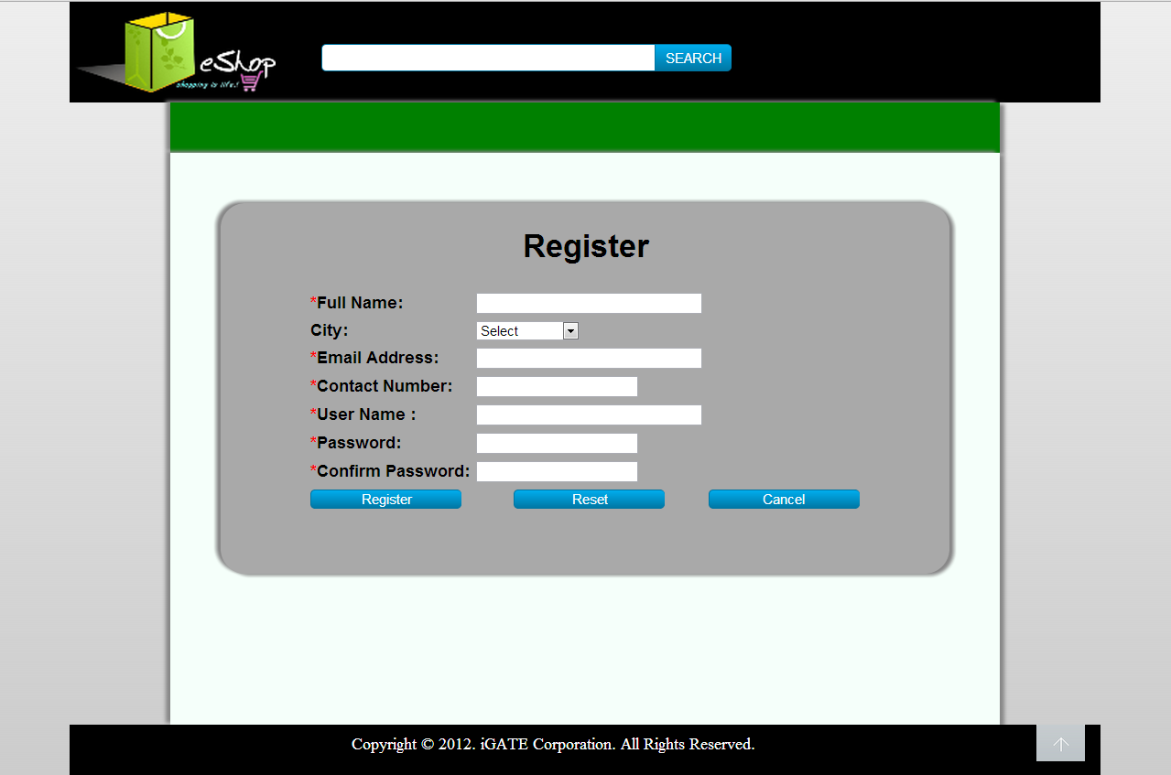

List Of Design Classes

Sr. No. | LLD Name | Class Name | Method Name | Method Description
1 | Register Module | Customer | Appropriate getters and setters methods | Getters retrieve the property values and setters set the property values
2 | Register Module | EshopController | prepareRegister(Model model):String  checkRegister(@ModelAttribute  (“customer”)@Valid Customer customer, ,BindingResult result ,Model model):String | Sets the model attribute.  Calls registerUser() of EshopBOImpl class which in turn calls registerUser() of EshopDAOImpl and the details of  visitor are entered into the database.
3 | Register  Module | EshopBOImpl | registerUser(Customer customer):int | Calls registerUser() of EshopDAOImpl class and returns the result to EshopController.
4 | Register  Module | EshopDAOImpl | registerUser(Customer customer):int | Adds the details to the database and returns the result to EshopBOImpl.

Re-Usable Routines/Components

Re-Usable Routines/Components

- CSS files
- Javascript files
- DataAccessException class
- Database properties files
- Logger properties files

Messages

#. | Type | Message Text
M1. | Error | Full Name cannot be left blank
M2 | Error | Enter a valid Full Name
M3 | Error | User Name cannot be left blank
M4 | Error | Enter a valid User Name
M5 | Error | User name must be less than 10 characters
M6 | Error | Email Id cannot be left blank
M7 | Error | Enter a valid email Id
M8 | Error | Password cannot be left blank
M9 | Error | Password must be less than 16 characters
M10 | Error | Confirm Password cannot be left blank
M11 | Error | Password Mismatch
M12 | Error | Contact Number cannot be left blank
M13 | Error | Enter a valid contact number
M14 | Error | Contact number must be less than 10 characters long

Configuration Files

File Name | Path | Description
oracle.properties | /Development/Source | To configure database connection.
Web.xml | /Development/Source | To configure the bean properties.
Dispatcher-servlet.xml | /Development/Source | To configure the request mapping and view resolver.
Eshop_logger.properties | /Development/Source | To configure the logger.
Eshop_error.properties | /Development/Source | To configure error messages.

Crud Matrix Table

# | Table Name | Create | Read | Update | Delete
1 | User | Y | N | N | N
2 | Customer | Y | N | N | N

Data Mapping Matrix

Sr. No. | Screen Label | Field Source | Field Type | Data Type | Max Length | Data Flow | Mandatory
1 | Full Name | N/A | Label | N/A | N/A | UI | N/A
2 | txtCustomerName | Customer.  customerName | TextBox | Varchar2 | 30 | UI→D | Yes
3 | User Name | NA | Label | N/A | N/A | UI | N/A
4 | txtCustomerId | Customer.  customerId | TextBox | Varchar2 | 10 | UI→D | Yes
5 | City | N/A | Label | N/A | N/A | UI | N/A
6 | optCustomerCity | Customer.  customerCity | ComboBox | Varchar2 | 30 | UI→D | Yes
7 | Email Address | N/A | Label | N/A | N/A | UI | N/A
8 | txtCustomerEmailId | Customer.  customerEmailId | TextBox | Varchar2 | 30 | UI→D | Yes
9 | Password | N/A | Label | N/A | N/A | UI | N/A
10 | txtPassword | User.password | TextBox | Varchar2 | 20 | UI→D | Yes
11 | Confirm Password | N/A | Label | N/A | N/A | UI | N/A
12 | txtConfirmPassword | User.password | TextBox | Varchar2 | 20 | UI | Yes
13 | Contact Number | N/A | Label | N/A | N/A | UI | N/A
14 | txtCustomerMobile  Number | Customer.  customerMobile  Number | TextBox | Varchar2 | 10 | UI→D | Yes
Sr. No. | Screen Label | Field Source | Field Type | Data Type | Max Length | Data Flow | Mandatory
15 | Register | NA | Button | NA | NA | UI | NA
16 | Reset | NA | Button | NA | NA | UI | NA
17 | Cancel | NA | Button | NA | NA | UI | NA

Legend

UI (User Interface Only)
UI → D (User Interface to Database)
D → UI (Database to User Interface)

Action Flow Matrix

Sr. No. | Action | Description | Process
1 | On click of Register Button | Valid User details are stored in to the database. | Customer details are validated if valid details are added to database the customer is navigated to Home Page, else he/she is navigated to the error page.

Stored Procedures

# | Stored Procedure Name  (with Description) | Input/Out Parameters | Type | Size
1. | NA | NA | NA | NA

Program Specification / Pseudo Code

14. 1 <ACTION: ONPAGE_LOAD>

Pseudo Code:

- Client Side Scripting
None
- Server Side Scripting

BEGIN
Calls prepareRegister(Model model) in EshopController class.
Navigates to Register Page.
END

14. 2<ACTION: REGISTER_CLICK>

Pseudo Code

- Client Side Scripting:

IF Full Name Filed is Empty
Print Error Message M1
IF Full Name is Invalid
Print Error Message M2
IF User Name Filed is Empty
Print Error Message M3
IF User Name is Invalid
Print Error Message M4
IF User Name >10 characters
Print Error Message M5
IF Email Id Filed is Empty
Print Error Message M6
IF Email Id is Invalid
Print Error Message M7
IF Password Filed is Empty
Print Error Message M8
IF Password length is >16
Print Error Message M9
IF Confirm Password Filed is Empty
Print Error Message M10
IF Confirm Password not same as Password
Print Error Message M11
IF Contact Number Filed is Empty
Print Error Message M12
IF Contact Number is Invalid
Print Error Message M13
IF Contact Number length is >16
Print Error Message M14

- Server Side Scripting:
BEGIN
Call prepareRegister (Model model) in EshopController class in Presentation Layer
BEGIN
Call registerUser(Customer customer) in EshopBOImpl class in Service Layer
BEGIN
Call registerUser(Customer customer) in EshopDAOImpl class in Data Access Layer
BEGIN
Create query to insert data in to User and Customer table
Return integer indicating if inserted or not
END
The result of the query is stored in an integer variable.
END
Return integer value to Service Layer
END
Return integer value to EshopController
END
IF true navigate to Home Page
REVISION HISTORY OF THE WORK PRODUCT

# | Date | Version # | Section Changed | Details of changes made | Approved By
1 | 16/12/2013 | 1.0 | LLD prepared | N/A | Uma M Ponniamman
2 | 17/12/2013 | 1.1 | Reusable components,  Pseudo Code,  Data Mapping Matrix. | Reusable components added.  More specific control flow specific.  More rows were added specifying the buttons of the form. | Uma M Ponniamman
3 | 18/12/2013 | 1.2 | Reusable components,  References,  Data Mapping Matrix. | Reusable Components added.  File name with relative path is added in the references section.  The name of text boxes(screen label is changed). | Uma M Ponniamman
4 | 20/12/2013 | 1.3 | Messages | Changes made in Error Messages. | Uma M Ponniamman
5 | 24/12/2013 | 1.4 | Configuration files,UI Components | Paths of the configuration files is updated and UI components(Screen Shots) added. | Uma M Ponniamman

